MILESTONE ACADEMY
VACATION HOME-WORK
SUBMISSION DATE – 17.06.19 CLASS – VIII PC/MS/2019-20/VIII/013
-------------------------------------------------------------------------------------------------------------------------------------------------
ENGLISH - 1. Write an account on Ventriloquist (in 50-75 words) :-
Hints: 1) What is the job of a Ventriloquist?
2) If you become a Ventriloquist, how would you entertain the audience?

2. Make a chart on Tenses.
3. Write a letter to a non Indian friend, who lives abroad giving him an idea of the life in
your town or village.
4. Write a paragraph beginning with “It was dark, I heard a loud noise ………….”
5. Read the situation given in column A and match them with the suitable similes
given in column B
Column A Column B
- The girl never tells the truth a. He sits there like a bump on a log
- Please water that plant b. She can sing like an angel
- That girl won’t harm anyone c. She looks as white as a ghost
- The water has frozen d. She lies like a rug
- He does not eat very much e. It’s as dry as bone
- She sings with much feeling f. She is as gentle as a lamb
- The patient looks very ill g. It as hard as a rock
- The boy is very lazy h. He eats like a bird

6. Solve the following puzzle by filling in the antonyms of the words given below
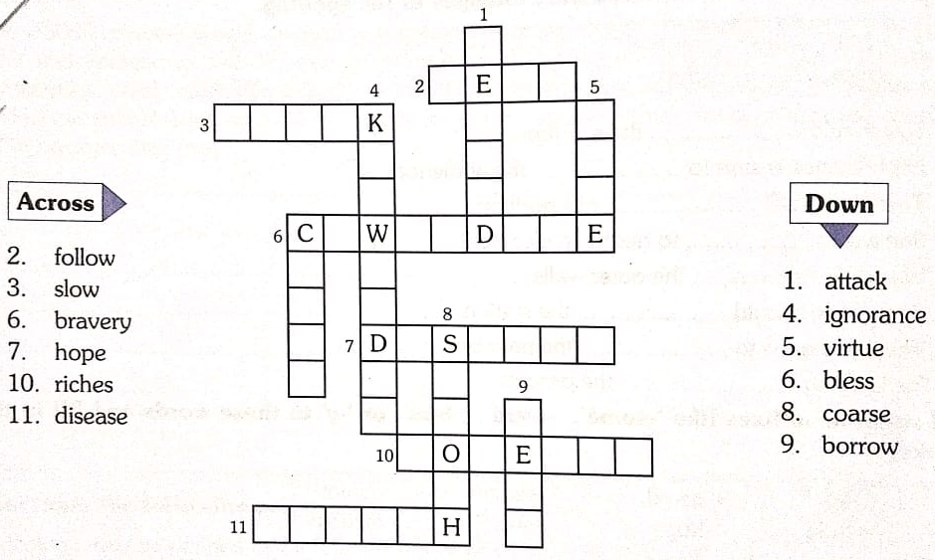

HINDI- – 1 dky ds fofHkUu izdkjksa dks mnkgj.k lfgr fyf[k, A
2-fdlh nSfud lekpkj i= ds laiknd dks 'kgj esa c<+rh tk jgh cl & nq?kZVukvksa ij fpark
izdV djrs gq, i= fyf[k, A
3- ijh{kk esa le; ij mifLFkr u gks ikus dk dkj.k O;Dr djrs gq, fo|ky; ds iz/kkukpk;kZ
dks izkFkZuk i= fyf[k, A
4- fu%”kqYd iqLrdsa izkIr djus ds fy, vius fo|ky; ds iz/kkukpk;kZ dks izkFkZuk i= fyf[k, A
- 'kgj esa gksus okyh ldZl ;k tknw & 'kks ds fy, foKkiu fyf[k, A

- Hkz"Vkpkj dh leL;k ij nks ukxfjdksa dk okrkZyki fyf[k, A
- vuqPNsn ys[ku 1-isVªksy dh c<+rh dhersa
ladsr fcanq &
- isVªksy dh mi;ksfxrk
- vke vkneh ij çHkko
- ljdkjh nkf;Ro
2- IykfLVd dk c<+rk pyu
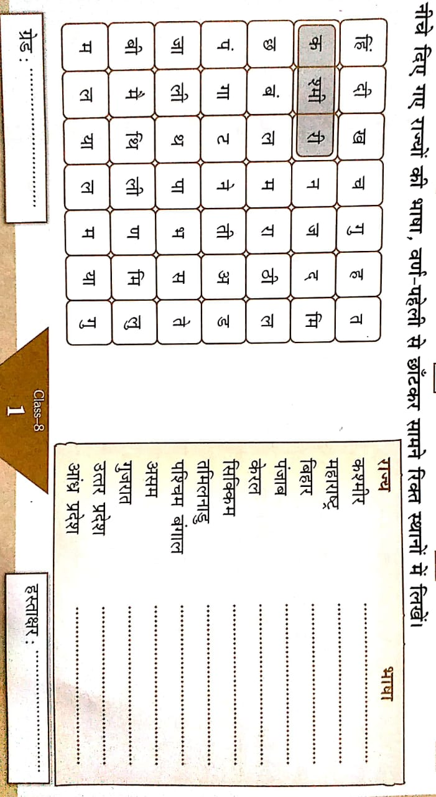
ladsr fcanq &
- IykfLVd ds mi;ksx ls çnw"k.k dh leL;k
- gkfu;k¡
- lek/kku
- vius ikB~; iqLrd ds ikBksa ls izR;sd v{kjks ds dfBu “kCn <wa<dj muds vFkZ fy[kdj
“kCndks”k (Dictionary) cukb,A

SANSKRIT - 1-ydkj & 1- yV~ydkj 2- yXydkj 3- y`V ydkj
4- yksV~ydkj 5- fof/k fyaXk ydkj ¼ik¡pks ydkjks esa½
2- /kkrq & [kkn~ ] xe~ ¼xPN½ ] ik ¼fic~½ ] Le` ] d` ] dzhM~
3- dkjd #i & laKk 'kCn & ekr` ] Lol` ] jktu~
4-loZuke 'kCn & vLen~ ] ;q"en~ ] ;r~ ] bne~ rhuks fyaxks esa
5-vO;; & rfgZ iqjr% ] ifjr%] vgfuZ”ke~ ] fud"kk%] lkEizre~ dk vFkZ @ iz;ksx
6- vuqNsn ys[ku & n”k okD;kfu jp;r
- iqLrdky;e~
eHtw"kk & ¼iqLrdkfu ] lHkkxkj% ] iqLrdkyL; ] v/;{kk ] Nk=k% ] iBfUr ]
vusdkfu ] fp=dFkk ] lqlfTtr ] vuq'kklue~ ½
- vknZ”k Nk=%
eHtw"kk & ¼fo|ky;s ] iz.kE; ] vfHkoknua ] fiz;a ] vuq”kklue~ ] lqlaLdkj% ]
fnup;kZ ] lgk;r;k ] okn fookn ] izfr;ksfxrka ½

SOCIAL SCIENCE – 1. Prepare 20 objective questions & answers each from History Ch-1 & 2,
Geography Ch-1 and Civics Ch 1 & 2
HISTORY – (i) Ch-1 Make an illustrated a project on kings who fought for Freedom .
(ii) Make a date dictionary with the events of Ch-1&2

GEOGRAPHY – (i) Make a synopsis on the topic ‘Resource’ with their details.

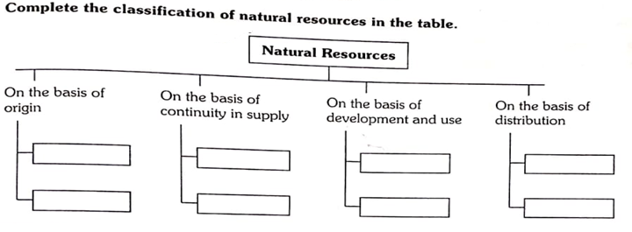

CIVICS

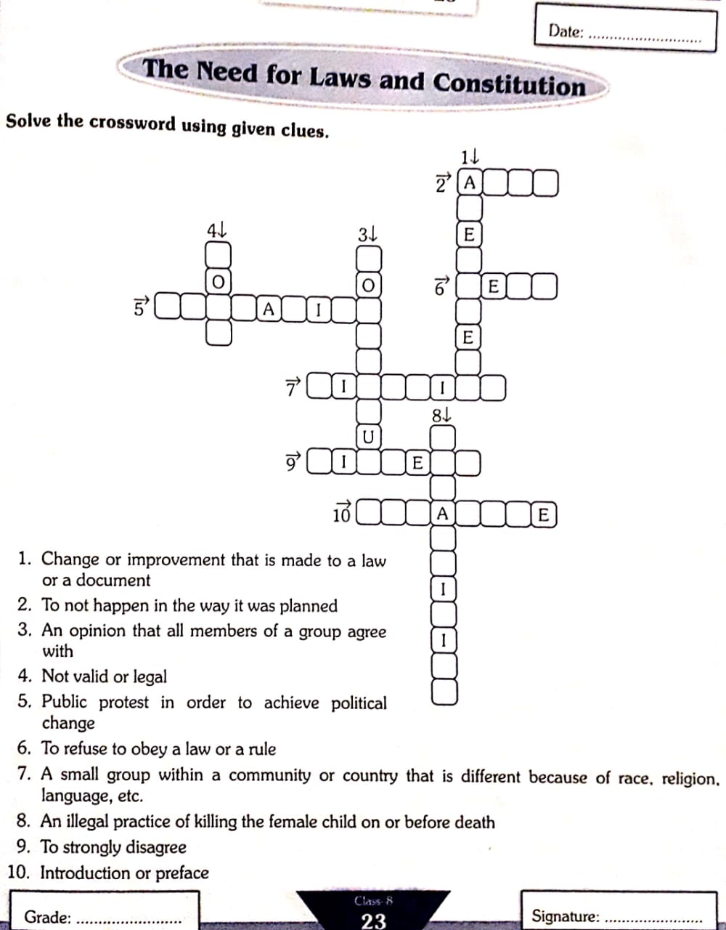

MATHS – 1. Collect different slips from bank and write details .
2. Collect the data and find out the mean and mode of the observations.
3. Explain Rational Number Properties.
4. Write down twice multiplication tables from 9 to 20.
5. Write the square and cubes of natural numbers from 1 to 20
6. Evaluate $\frac{3}{5}+\frac{7}{3}+\frac{-11}{5}+\frac{-2}{3}$
7. The sum of two rational numbers is (-1/2) . If one of the numbers is $\frac{5}{6}$ , find the other no.
8. What number should be subtracted from $-\frac{2}{3}$to get $-\frac{1}{6}$
9. Verify :- $-\frac{15}{4}×\left(\frac{3}{7}+\frac{-12}{5}\right)=\left(-\frac{15}{4}×\frac{3}{4}\right)+\left(-\frac{15}{4}×-\frac{12}{3}\right)$
10.The product of two numbers is $-\frac{28}{27} .$ If one of the numbers is $–\frac{4}{9}$. $Find the other number.$
11. By what number should $-\frac{33}{8}$ be divided to get $-\frac{11}{2}?$
12. Divide the sum of $\frac{13}{5} and\frac{-12}{7}$ by the product of $-\frac{31}{7} and\frac{1}{-2}.$
13. Find a rational number between $-\frac{1}{3} and\frac{1}{2}$
14. Find two rational numbers between -3 and -2.
15. In a school, $\frac{5}{8}$ of the students are boys. If there are 240 girls. Find the number of boys
in the school.

16. The sum of the digits of a two-digit number is 15. If the number formed by reversing
the digits is less than the original number by 27. Find the original number. Check
your solution.
17. Two numbers are in the ratio 8:3, If the sum of the numbers is 143. Find the numbers.
18. The width of a rectangle is two third of the length. If the perimeter is 180 metres.
Find the dimensions of the rectangle.
19. Two angles of a triangle are in the ratio 4:5. If the sum of these angles is equal to
the third angle, find the angles of the triangle.
20. Find three consecutive odd numbers whose sum is 147.

SCIENCE – 1) Write short note on Synthetic Fibres and its different types. Paste different types of
Synthetic Fibres. (2x2 inch).
2) Prepare a project on “Useful and harmful microbes”
3) Elaborate on various agricultural practices undertaken for cultivation of crops.
4) Being a material of choice how plastic is affecting the environment. Explain.

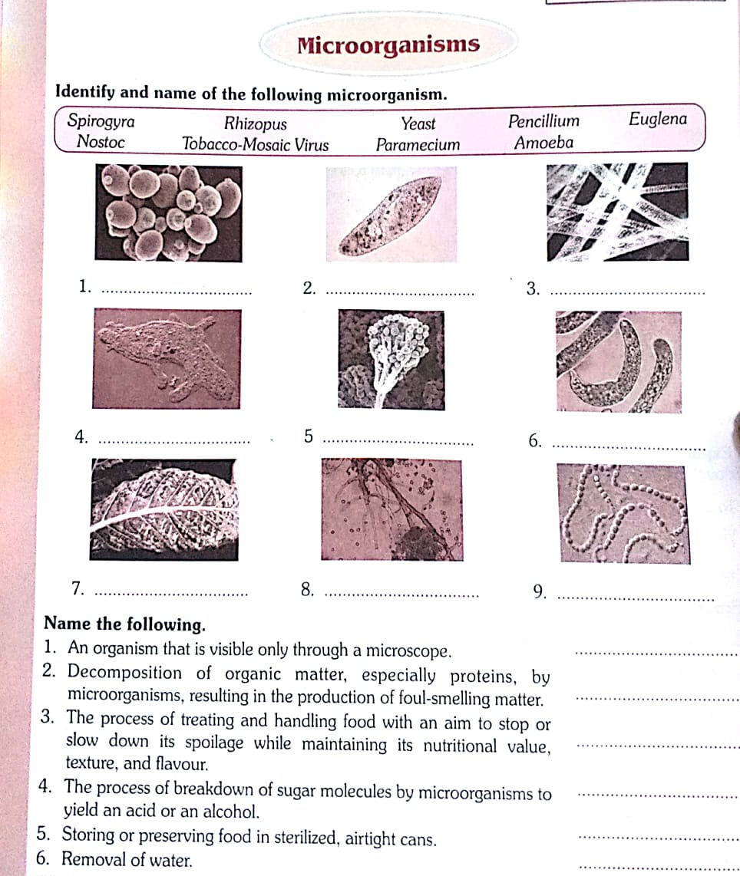

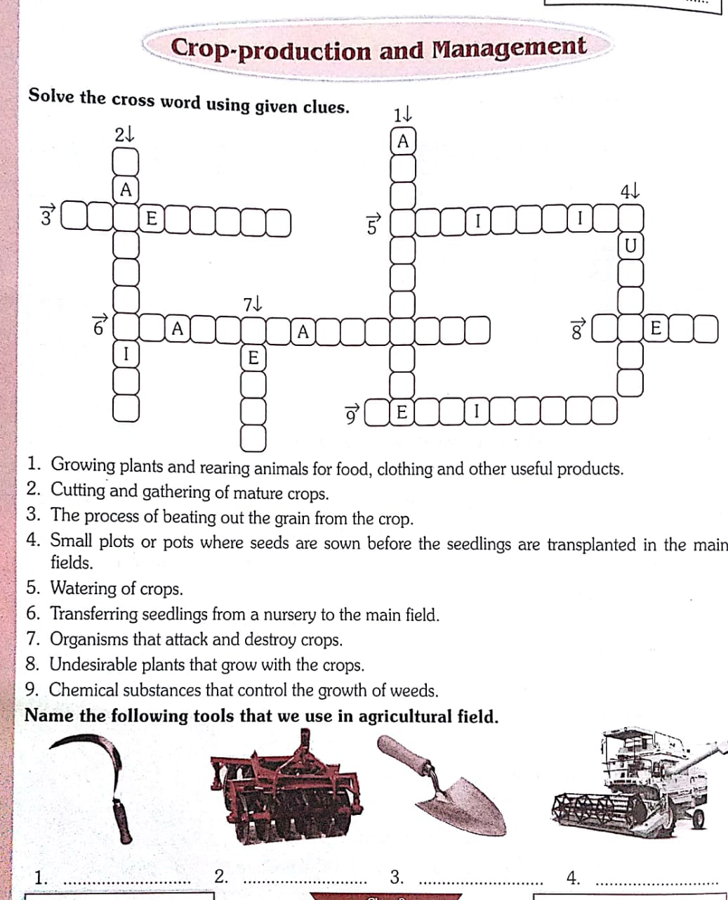

COMPUTER – Refer to the local newspapers or the internet for the weather data for a month. Enter the
value in a spreadsheet and create charts for the data. Create different types of the charts
and paste on the chart paper.

CREATIVE EXPRESSION - “My Favourite Family Teacher.”
Record and write the conversation done with your favourite family member/or friend during summer vacation
Eg. - Written conversation
Grandma – Very Good Morning to you .
Grand daughter / son - Good morning Grandma.
Today what a chirpy morning it is !
Grandma - So how are you making this morning beautiful?
Grand daughter / son - After breakfast I am visiting my friends place to play.

LIFE SKILL - Think of one person whom you have disrespected. Imagine that you have a time machine and you can go back in time to the moment when you were disrespectful to this person. Now that you understand what RESPECT means, write about how you would choose to show respect to this person. (Hint: Use feeling words, eg: hurt)

